1. <https://www.youtube.com/watch?v=hyBznKcoKEg>
2. 
3. Before doing any development, we need to do some setup.
4. 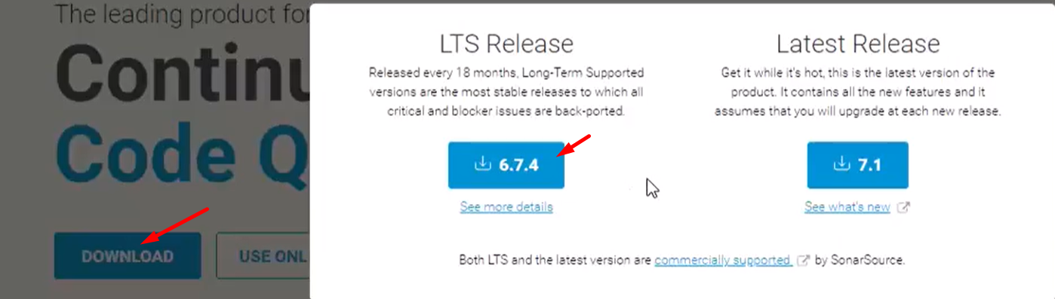
5. 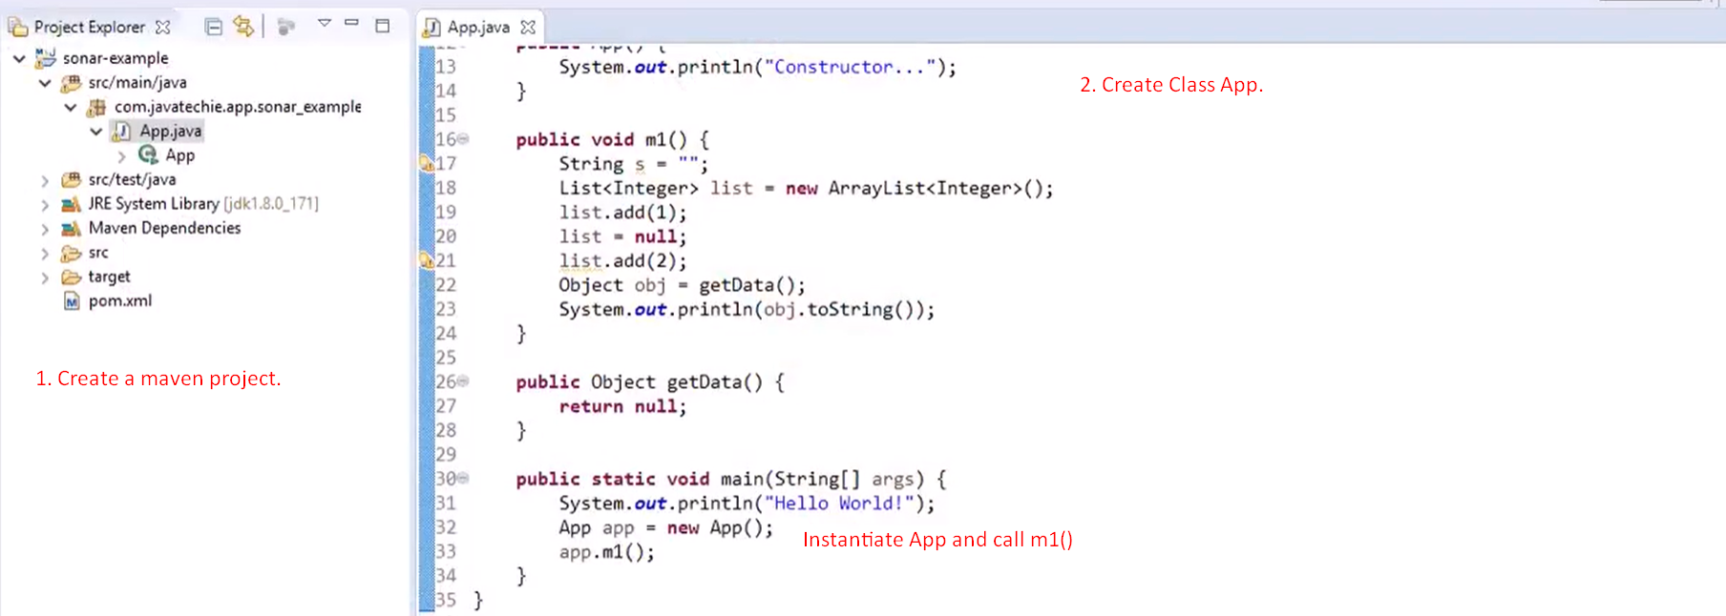
6. 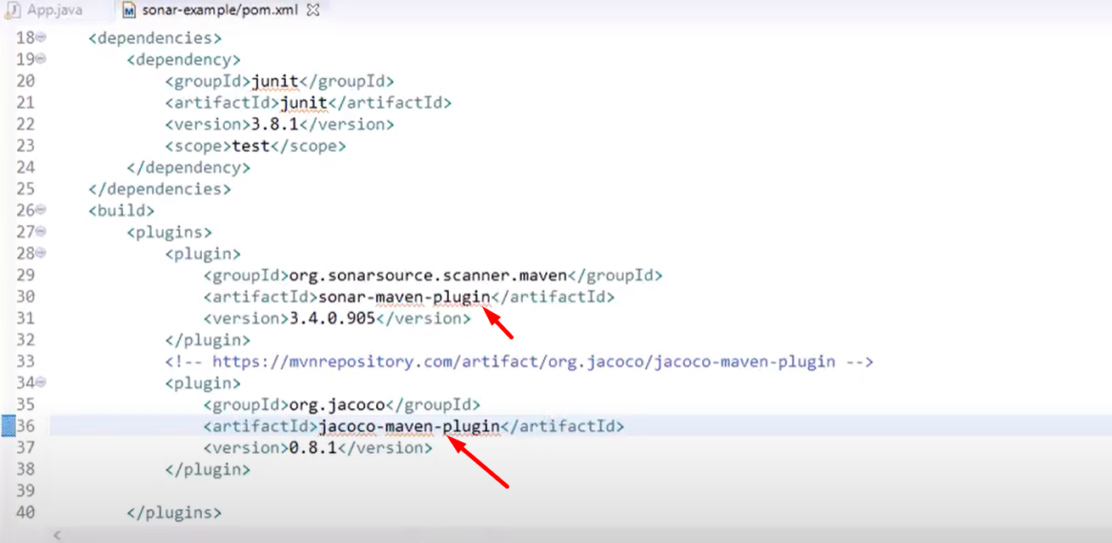
7. 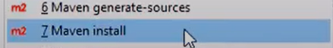
8. 
9. 
10. 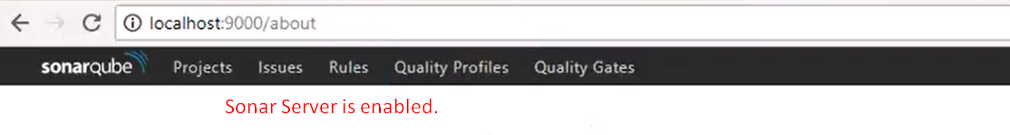
11. 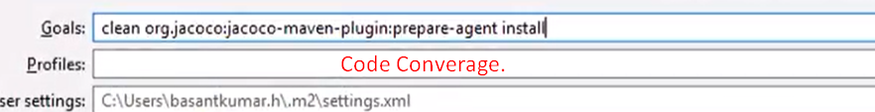
12. 
13. 
14. 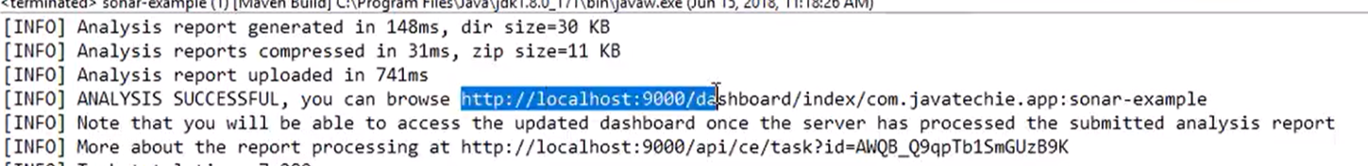
15. Start from here 🡺 <https://youtu.be/hyBznKcoKEg?t=653>